Technical Documentation: Covid 19 Registration Portal

Peter Nguyen

Student ID: 013602446

Instructor Christopher Pham

EE 104: Applied Programming in Electrical Engineering

Due Date: 02/15/2023

Table of Contents

Video Execution of Program 3

Program Description 4

Common Errors and Bugs 5

Visual Code breakdown 6

Modules used to generate program 6

Excel Sheet Caller 6

Account Linker 6

Excel Column Additions 7

Clear Registration Form Contents 7

Error Pop-up 8

Submission Success Pop-up 8

Sending text and email message generator 9

Second Vaccination Notification/Reminder (Text & Email) 11

Date confirmation 12

Excel Sheet Input and Format 13

Registration Form Visuals 14

Initializes variables 14

Label Creator and Formatter 15

Focus Fields 16

Registration Portal Illustrations 17

Success and failure popups 20

Delete Function Caller 21

# Video Execution of Program

The following video is a video briefly explaining my program as well as executing my program ensuring that the program successfully sends the proper messages as well as logs the proper information to their perspective excel files.

](https://www.youtube.com/watch?v=Ho5_tQbIzlo)

<https://www.youtube.com/watch?v=Ho5_tQbIzlo>

# Program Description

The purpose of this software application is to cater to the needs of dedicated nurses and medical professionals working diligently to administer vaccines to patients. Specifically, the program has been developed to simplify the process of patient registration and management for the health care providers.

After a patient has received their first vaccine dose, the user can enter the patient's personal information into the database to register their vaccination. The system then automatically generates notifications to the patient's email and phone, providing them with essential information regarding their second vaccination date.

It is worth noting that the program was initially created by Professor Christopher Pham. It is important to mention that all rights to the program belong to the professor, and our assignment for the course is to modify and enhance the program to meet specific requirements.

In summary, this program offers a valuable solution to the challenges faced by healthcare professionals in their mission to vaccinate patients. It streamlines the registration process and ensures efficient management of vaccine administration schedules. The program serves as a testament to the benefits of technological advancements in healthcare, and our task is to build upon the base code laid by Professor Pham to add additional fields and play around with the functions laid in the program.

# Common Errors and Bugs

In the program, the user can typically run into issues with the registration form not appearing after running the program on their IDE or Anaconda Spyder. The specific response that typically appears with this issue is “pyimage_ has not been found”. This appears when the IDE or Spyder faces issues with locating the image specified in the program. To fix this, its best that the user restarts their IDE entirely by closing the application and relaunching it as the module tkinter sometimes bugs out due to image formats.

Another error that also appears is when the program fails to move to the next step after submission in the registration form. This occurs when the registration form is filled with incorrect inputs, which the developer will need to locate the excel file where the information is being stored and delete the row containing the details entirely.

# Visual Code breakdown

While the program was mainly formed already by our professor, the program still required some modifications and additions to add complexity to the lab assignment as well as familiarity with the programming language. By reading through the program, students are able to understand the purpose of each module and line of code inputted into the program and be able to input their own lines. For this section of the document, I will be going over the importance of each module and the additions I made to the program.

## Modules used to generate program

Calls the modules to bring in additional functions and functionality to form entire program.

## Excel Sheet Caller

Identifies the excel sheets that will be used for the program and allows access to the excel sheet as long as the sheet is in the same location as the python program file.

## Account Linker

Allows access to twilio and gmail accounts based on the details inputted to successfully sync the account to the program.

## Excel Column Additions

This part of the program handles the additional columns being added to the excel file to hand the additional fields that were assigned for the assignment. This module is important for the program to initialize that new columns are being registered in the excel file and users are able to set the size of them as well.

## Clear Registration Form Contents

In this portion of the program, it sets the fields of each of the variables to be cleared once the registration form is successfully complete. This allows the program to reset the form for every submission.

## Error Pop-up

When the program detects an error in the registration form, login page, or account page, the user will be notified that an error has occurred and appeared with a popup. Its important to note that the program is very strict, so slight errors can cause the error to occur.

## Submission Success Pop-up

When the program detects the user input follows the right format and follows the database, the user will be able to see a success popup indicating that everything is going properly. The following code also explains how the pop-up is visually designed.

## Sending text and email message generator

This allows the program to notify the user the their second appointment will occur in the following two weeks to allow the user to be reminded of the shot. The program adds an additional 21 days for the user to be reminded of the date a few days before the appointment.

Message Contents:

Message Format:

## Second Vaccination Notification/Reminder (Text & Email)

Portion of code that calculates the date of the second vaccination shot by adding two weeks to the first date and also sends the second notification to clients email & number with a message notifying about their second shot.

## Date confirmation

Confirms with the user that the date after two weeks of the first shot is acceptable and allows user to send the second text once confirmed that the information is processed correctly along with confirmation of next appointment.

Text message format:

## Excel Sheet Input and Format

Allows registration information to be inputted into excel sheet database. Formats data into correct columns and rows while putting data into the correct format. Also allows data to automatically move to the next row as each registration is submitted.

## Registration Form Visuals

Sets the header and background to the registration form. The background is set with a parameter to look cleanly on the form while having a header indicating the page title.

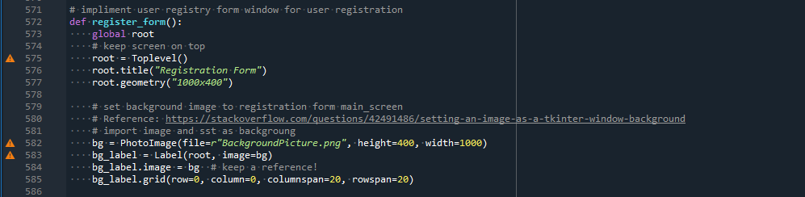

## Initializes variables

Sets the type for the variables to be initialized throughout the program. Allows the variable to be called multiple times to easily customize the features of the variables to be implemented in various areas such as the excel file, body message, and database.

## Label Creator and Formatter

Creates labels and buttons to the registration portal as well as creates dialogue indicating what information should be inputted in the box beside the label. Also assigns a position to each label based on a grid to allow each label to line up with each input box.

## Focus Fields

Allows the user to move to the next input box without having to click on the next box by pressing “enter” which automatically prepares cursor to allow inputting data to the next box.

## Registration Portal Illustrations

Creates labels and buttons to appear on the registration portal and allows input boxes to be assigned to specific positions of the portal for the user to input their username and password. The labels and buttons can be customized to have different sizes and colors here.

## Success and failure popups

Allows pop ups to appear when data is successfully and incorrectly inputted. Also sets the pop-up to only disappear when the user exits the pop-up or confirms with the pop-up.

## Delete Function Caller

Allows the user to exit each of the popup when it appears on their screen.

